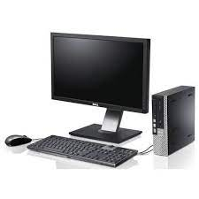

Black Dell Desktop

* Usage :Home, Office
* Resolution :1920x1080
* Connectivity :Usb
* Standard : 1600 MHZ
* **Rs.68,440**